1. TLS : During mutual TLS , what is exchanged ? encryption algorithm
2. If insecure checkbox is ticked, it bi passes the certificate validation ,hence no tls : IF set to true , no validation occurs
3. Identity of insecure is authenticated first and then client - prc of auth in tls? Ans: Authentication of server then authentication of client
4. one question for truststore like api is having CA certificates, then where can those certificates can be found in client, like jre truststore option -
5. For Encryption, what is mulesoft suggested ? different key and diff secure data/ credentials, for diff envs

1. **Syntax to convert jks to pks12 :** keytool -importkeystore -srckeystore [MY_KEYSTORE.jks] -destkeystore [MY_FILE.p12] -srcstoretype JKS -deststoretype PKCS12
2. One ques on secure property , ans: ${secure::{key.value}}
3. <secureProperties> in cloudhub 2.0 - ans : masked at runtime
4. How to handle permanent errors in until successful ? wrap it in try block and use on error continue
5. One ques on Error Handling
6. VM :On prem severs, data stored in vm queue n server is down , what would happen - ans : In Persistent queues, the data will be retained /transactionn completed and will be accessible once the server is up and running
7. VM: On prem , if applications wants to use VM ? *2 replicas should have the same domain*

node cluster of 2 in customer hosted runtime, VM queues are used? how both can use to share data async

1. Anypoint MQ: Data coming from apis , how would you listen to all at the same time? Ans :Publish the app to exchange, create MQS and bind them to exchange , one api event . Other 5 apis are listening, how will you share the event? (like mq, exchange, how will you bind them)
2. How to Capture outbound HTTP requests? Ans: HTTP Policy Operation
3. PGP Encryption, ans : you need a public key from backend to accept the data
4. File size >10 MB , wanna access the file across the applications, how ?Ans : store it in a location , access using it from the object store by providing the file location (as value) , key and value
5. One question on OS TTL - null/testpayload
6. REST API Object Store v2 - how do you exchange data among 2 diff applications
7. Maven Life cycle phases . ans : Validate, Compile, Test, Package, Integration test, Verify, Install, and Deploy
8. A1,B1,F1,B2,A2 , one question on policies
9. In Log4j2 , to log errors what needs to be modified ? ans : <AsyncLogger name="org.mule.service.vm" level="ERROR"/ > inside the loggers log
10. If there is no code written to cache , how is caching implemented by cache component internally ? ans: it uses the concept of TTL
11. best way to add/append **account id** in all the logs of an application (tracing module, create a xml-sdk component and use it)
12. Transmit correlation for anypoint MQ : Use Tracing module , wrap Anypoint MQpublisher within correlationId scope and set correlation ID to orderId
13. If there is no correlation received externally , http listener component creates one
14. Correlation id is auto propagated to the client
15. Munit plugin dependency name for testing : munit-maven-plugin

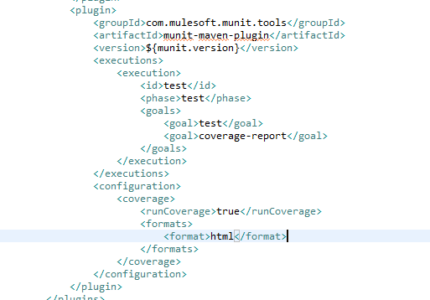

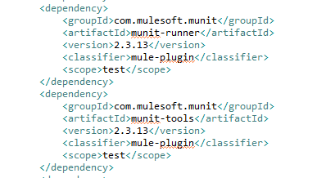

1. 2 flows, 2 responses , how to test using munits? Ans: use Set event to pass the input data that is needed, and keep the test cases for flow 1 and flow 2 independent.
2. In raml , a field is defined , datatype : integer/number, the field is given -1 , what error occurs ? - JSON_SCHEMA_NOT_HONOURED error
3. In raml, we have defined two 403 forbidden and 400 bad request, client_id and secret are not passed during the api call , what would happen ? ans: 403 access forbidden
4. Raml how can 2 versions of same api can be kept live- use v1,v2 in the base path of the url
5. To exclude a certain file from applying a policy : wrap them in exclude tag

*<build>*

*<resources>*

*<resource>*

***<directory>src/main/resources</directory>***

*<filtering>false</filtering>*

***<excludes>***

***<exclude>**/application-dev.yaml</exclude>***

***</excludes>***

*</resource>*

*</resources>*

*</build> or*

*<build>*

*<resources>*

*..*

*<plugin>*

***<configuration>***

***<nonFilteredExtensions>***

***<nonFilteredExtension>pem<nonFilteredExtension>***

***<nonFilteredExtensions>***

*Non-filtered-resources ?*

*Install into local repo and use that as dependency in pom.xml , java code*

1. What configurations to include to create a library ? ans:  *to build as a reusable library , the classifier should be mule -plugin and import that as dependency in the project to use*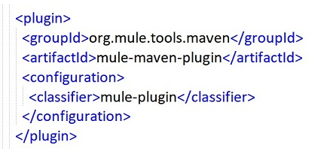
2. Scatter gather : rollback
3. Apply try catch block on flow reference not on the scatter gather (diagram based question)
4. how to retrive error of 3 rd failure route in scatter gather

error.errorMessage.payload.failures['2']

1. SG : one ans saga orchestration , set partial response in case one route is timed out in scatter gather

**A Mule flow uses the Scatter-Gather router to execute requests in parallel to two external web APIs using HTTP. If one route fails, all routes must be returned to their original states.**

**Which implementation will return the routes to their original states?**

1. Wrap the Scatter-Gather router in a Try scope with a transactional action; all routes will automatically roll back
2. **Extract the successful route from the Scatter-Gather result, and execute logic required to undo the successful route**
3. Extract the failed route from the Scatter-Gather result, and execute logic required to undo the failed route
4. Set the Scatter-Gather concurrency to a value of "1" so that only one route is executed at a time, and stop processing before executing any subsequent routes

**Refer** - Saga pattern

1. . ip whitelisting policy is applied? want to test it on local machine in studio? (disable gatekeeper/give random api ID)
2. Oauth policy is applied. Due to slowness, Caching policy is applied first? what will happen in case of miss / hit options?
3. where will you add common plugin configs in pom.xml / **parent pom.xml** / bom.xml - ans: **parent-pom : deployment for configurations for diff apps**
4. Which file to modify in mule project before deploying? pom.xml
5. Health check : use the **same port** for the health check as the listener in the api itself
6. Health check , ans : dedicated endpoint that gives **API Status and reachability** of the end system

best way to have readiness health endpoints (like same port, different port, any endpoint or dedicate one, should it also check if end system connectivity or not)

1. for api which needs high availability, should the health check endpoint write data to external system? NO
2. One ques on c4E,-reusability : publish to exchange and reuse it , as a dependency
3. Error handling one question , similar to MCD L1
4. If you wanna build a global error handler and use it across projects what would you do ? ANS:must be added as a dependency in the application and import that file into the project ,

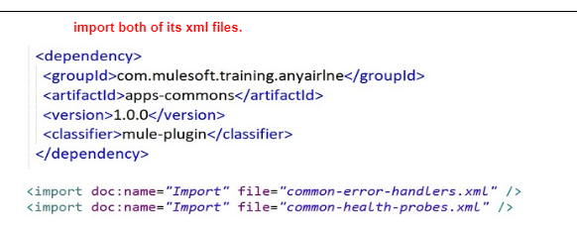

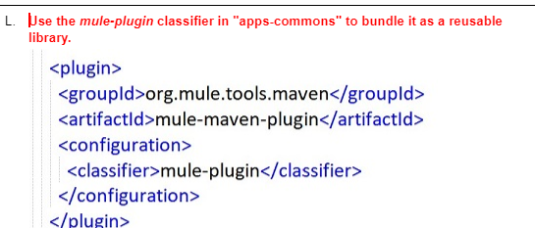

1. what access is required to accept client request

options : creating sla tiers

creating sla tiers and admin for platform

creating sla tiers, and contract exchange permissions, Env admin access, & one more

ANS: Exchange administrator permission

1. Anypoint monitoring , inside the custom dashboard, go to specific application, see metrics u can see the logs, what's the exact ans ?  **log management->rawdata**
2. Oauth conf ? ans : local authorization url, authorization url, ClientId, secret, access token url ,call back url
3. legacy code, new code developed in java, how to use it in an API: refer it in pom.xml and bring into local repository,add the jars to the code as library/dependency
4. . best monitor functional monitoring for 10 api deployed in cloudhub public : Answer: public/public location monitor calling all 10 api in their scheduler/ all together
5. How do all validations work with multiple fields validation like validation of email, validation of date and validation of name? - **ans: if only email add is invalid, VALIDATION:INVALID EMAIL error is raised**
6. in titanium subscription, how will you find average request and response time for salesforce connector? Ans: custom dashboard in AP monitoring
7. Cache-invalidate header , ans : x-cache-invalidate-header : invalidate or invalidate-all (for server-side caching , invalidate header can be provided in UI while applying cache policy in Anypoint Platform)
8. Cloudhub 2.0
9. Client initiates a request and the response will not be sent immediately, might take time, what approach should we take.Ans: callback url
10. Question on maxConcurrency in Scatter Gather
11. Question on how to consume a API from exchange in studio while creating a mule project. options - import raml,download raml, import published API
12. Organization wants to check the the health of the application what approach it should follow. Ans ? (monitoring,health end points)
13. **A scheduled batch processing Mule application interacting with multiple other Mule applications over HTTP must send a custom correlation ID in the format of *"application name"-UUID* to each application.**

**What is required to configure the client application to send this custom correlation ID?**

1. *Set a value for HTTP header x-correlation-id with each request with the value:*

*#['x-correlation-id':myapp-$(uuid())']*

1. Set a global property with name: *correlationId* and value: *"#['myapp-$(uuid())']*
2. Use the set-variable processor to set a variable with name: *correlationId* and value: *"#['myapp-$(uuid())']*
3. **Set the global configuration correlationIdGeneratorExpression attribute with the value: "#['myapp-$(uuid())']**

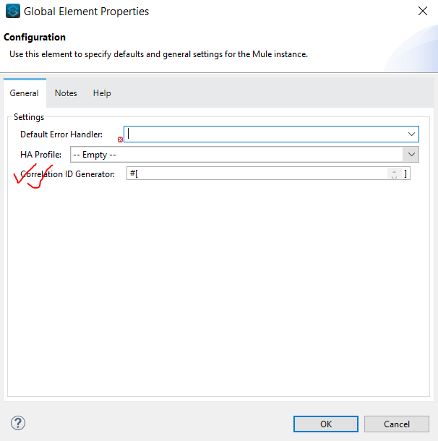

**Reference:**

1. **Refer to the exhibits.**

**The process-api-flow calls the system-api-flow over HTTPS.**

**Self-signed certificates are used to set up SSL/TLS connection.**

**What is the minimum TLS configuration required to make the call work?**

h

1. system-api-flow's HTTPS Listener needs a keystore and process-api-flow's HTTPS Request needs a truststore
2. **system-api-flow's HTTPS Listener needs a keystore**
3. process-api-flow's HTTPS Listener needs a keystore and system-api-flow's HTTPS Listener needs a keystore
4. process-api-flow's HTTPS Listener needs a keystore

**A customer is building APIs for a digital transformation program and wants to monitor the health of their APIs.**

**Which two methods or tools can be used to check the health of these APIs? (Choose two.)**

1. Existing resource endpoints
2. API Manager policies
3. API mocking service
4. **Dedicated health check endpoints**
5. **API Functional Monitoring**

**======================================================================================================================================**

**Refer to the exhibits.**

**The command *mvn clean package* issued on a Mule application, which is a standalone Maven project, results in a build failure.**

**Which two changes will result in a successful build? (Choose two.)**

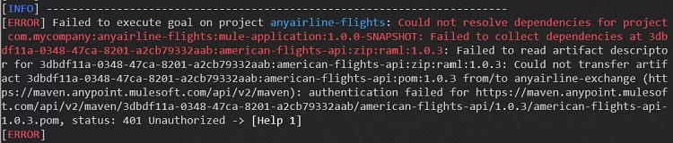

1. **Add to pom.xml**

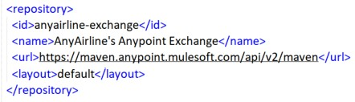

1. **Add to settings.xml**

**(AP: Anypoint Platform)**

